**Lecture 1**

What is a project and job?

“A specific plan or design- e.g. a public works scheme”

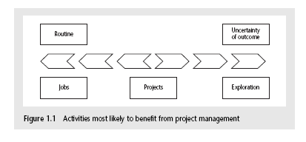

Jobs: repetition of very well-defined a tasks with very little uncertainty

Exploration: e.g. finding a cure for cancer: the outcome is very uncertain

Projects: in the middle!

Characteristics of projects: A task is more ‘project-like’ if it is:

* Non-routine
* Planned
* Aiming at a specific target
* Work carried out for a customer

Are software projects really different from other projects?

Not really! ...but there are

1-Invisibility 2-Complexity 3-Conformity 4-Flexibility

How/ why do Software Projects Go Wrong?

Bad design

Reinvent the wheel

When there are problems with system software it could much cost

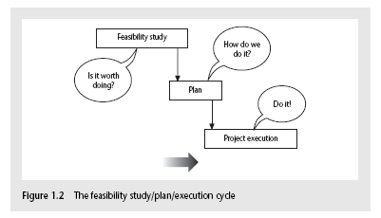

What Activities covered by project management?

Feasibility study: Is project technically feasible from a business point of view?

Planning: Only done if project is feasible

Execution: Implement plan, but plan may be changed as we go along

The software development life-cycle

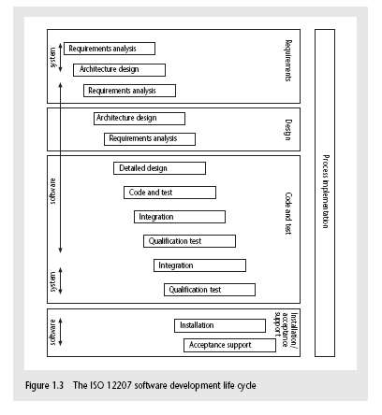

**ISO 12207 life-cycle**

Requirements analysis

* What does the client need?
* Analysis: converting ‘customer-facing’ requirements into equivalents that developers can understand
* Define (Functions-Quality- costs)

Architecture design

* Based on system requirements
* Defines components of system: hardware, software, organizational

Code and test

* Of individual components Integration
* Putting the components together

Qualification testing

* Testing the system (not just the software) Installation
* The process of making the system operational
* Includes setting up standing data, hardware, platforms, user training etc.

Acceptance support

* Including maintenance and enhancement

Some ways of categorizing projects

Distinguishing different types of project is important as different types of task need different project approaches e.g.

* Compulsory users and voluntary users
* Information systems versus embedded systems
* Objective-based versus product-based

How to set objectives?

Answering the question ‘What do we have to do to have a success?’

Need for a project authority

* Sets the project scope
* Allocates/approves costs

Could be one person - or a group

* Project Board
* Project Management Board
* Steering committee

What are the Objectives?

Informally, the objective of a project can be defined by completing the statement:

The project will be regarded as a success if......... (Conditions for the project).....

Objectives should be SMART?

S – Specific, concrete and well-defined

M – Measurable, satisfaction of the objective

A – Achievable, it is within the power of team concerned to meet the target

R – Relevant, the objective must relevant to the true purpose of the project

T – Time constrained: time point at which the objective should be achieved

Difference between goals & sub–objectives ?

These are steps along the way to achieving the objective.

By completing the sentence...

Objective X will be achieved IF the following goals are all achieved

A (goal)...............>x

B............... >y

C............... > etc.

A goal: can be given to an individual.

Individual may have the capability of achieving goal, but not the objective on their own e.g.

Objective – user satisfaction with software product

Analyst goal – accurate requirements

Developer goal – software that is reliable

How do we know that the goal or objective has been achieved?

By a practical test, that can be objectively assessed.

E.g. for user satisfaction with software product:

* Repeat business – they buy further products from us
* Number of complaints – if low etc.

E.g. For reliability:

* Mean time between failures number of errors found during code inspections

Who are Stakeholders?

These are people who have a stake or interest in the project

They could be users/clients or developers/implementers:

* In the project team
* In the same organization
* Outside team and the organization

Measures Project success and failure?

* Agree functionality
* agree level of quality
* On time
* Within budget

Notes:

Project objectives vs. business objectives:

Business objectives: Benefits of delivered project must outweigh costs at: beginning, delivery and operation

What is management?

This involves the following activities:

1-Planning 2-Organizing 3-Staffing 4-Directing

5-Monitoring 6-Controlling 7-Innovating 8-Representing

Management Control Cycle:





**Lecture 4**

What is Activity Planning?

An indicator of the cost of constraints

Emphasis: - Meeting target time at minimum cost

- Completing the project in minimum time at minimum cost

One way to minimize time is to do activities in parallel. However:

* Precedence Requirements
* Resource Constraint

What’s the difference between Planning, Estimating, Scheduling?

Plan: Identify “what” needs to be done(activities). No specific start and end dates.

* Work Breakdown Structure (WBS)
* Product Breakdown Structure (PBS)

Estimating: Determining the size & duration of activities.

Schedule: Add specific start and end dates, relationships, and resources, dependency between tasks

Difference between Project and Activity?

A project is composed of a number of related activities

A project start when at least one of its activities starts

A project will be completed when all of its activities completed

An activity must have clearly defined **start and end** points.

An activity must have **resource** requirements that are forecastable.

An activity must have a **duration** that is forecastable.

An activity may be **dependent** on other activities being completed first (precedence).

Approaches towards to Identifying Activity?

Activity-based approach

* WBS
* Advantages: produce a task catalogue on non-overlapping activities

Product-based approach

* PBS / PFD
* Advantages: Less likely that a product is left out.

Which techniques for Identifying project products and activities?

1-Work breakdown structure (WBS)

2-Product breakdown structure (PBS)

3-Hybrid Approach

1-Work breakdown structure (WBS)

• A hierarchical list of project’s work activities that organizes and defines the total scope of the project work.

• Work not in the WBS is not in scope of the project.

• Each descending level represents an increasingly detailed description of the project elements.

* Each activity is broken down into tasks, until desired level of detail is reached
* Maximum task size is usually 10-20 hours
* Shows “is contained in” relationships
* Does not show dependencies or durations

What does a WBS look like? 2 Formats

1-Graphical Tree (Organizational Chart)

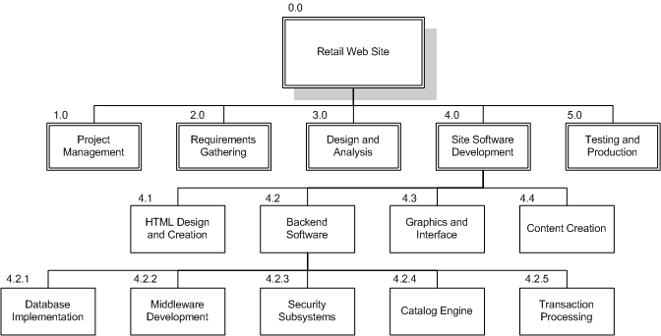

2-Outline (indented format)

WBS Outline Example:

0.0 Retail Web Site

1.0 Project Management

2.0 Requirements Gathering

…..etc.

What are Approaches for WBS?

Top-Down-->using a general-to-specific structures to progressively detail the work.

Bottom-Up-->Brainstorming all work to be done and then grouping into a hierarchy.

IBM recommended WBS

Level1: Project

Level 2: Deliverables: software, documents, and trainings

Level 3: Components: Key items needed to produce deliverables

Level 4: Work package: collections of related tasks required to produce a product

Level 5: Tasks: a task is usually the responsibility of one person

Guidelines:

* Should be easy to understand
* Ensure each element corresponds to a deliverable
* When to stop: Break down until you can generate accurate time & cost estimates

How detailed should it be?

* Not as detailed as the final MS-Project plan
* Each level should have no more than 7 items
* It can evolve over time

What tool should you use?

* Excel, Word, Project
* Org chart diagramming tool (Visio, etc.)

Re-use a “template” if you have one

2-Product breakdown structure (PBS)

* Another approach to Identify “what” needs to be done

Breakdown by products

* similar to WBS, but based on the structure of product rather than type of activities
* The top level of PBS is the final product
* Second level may consist of the major components of the product
* Lower levels in PBS describe the structure of item on level above

PBS Example

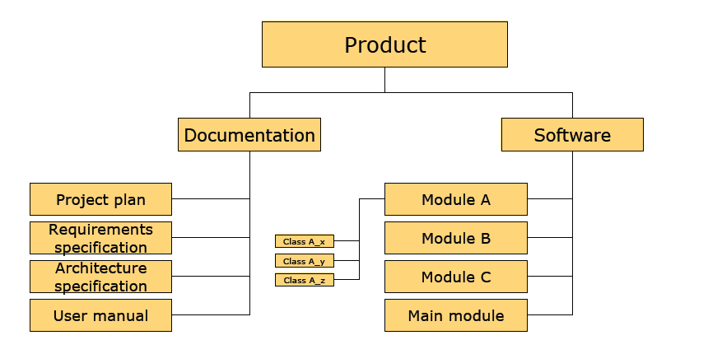

3- Hybrid approach

* Start with products (Based on deliverables)
* For each product, list activities required

Example:

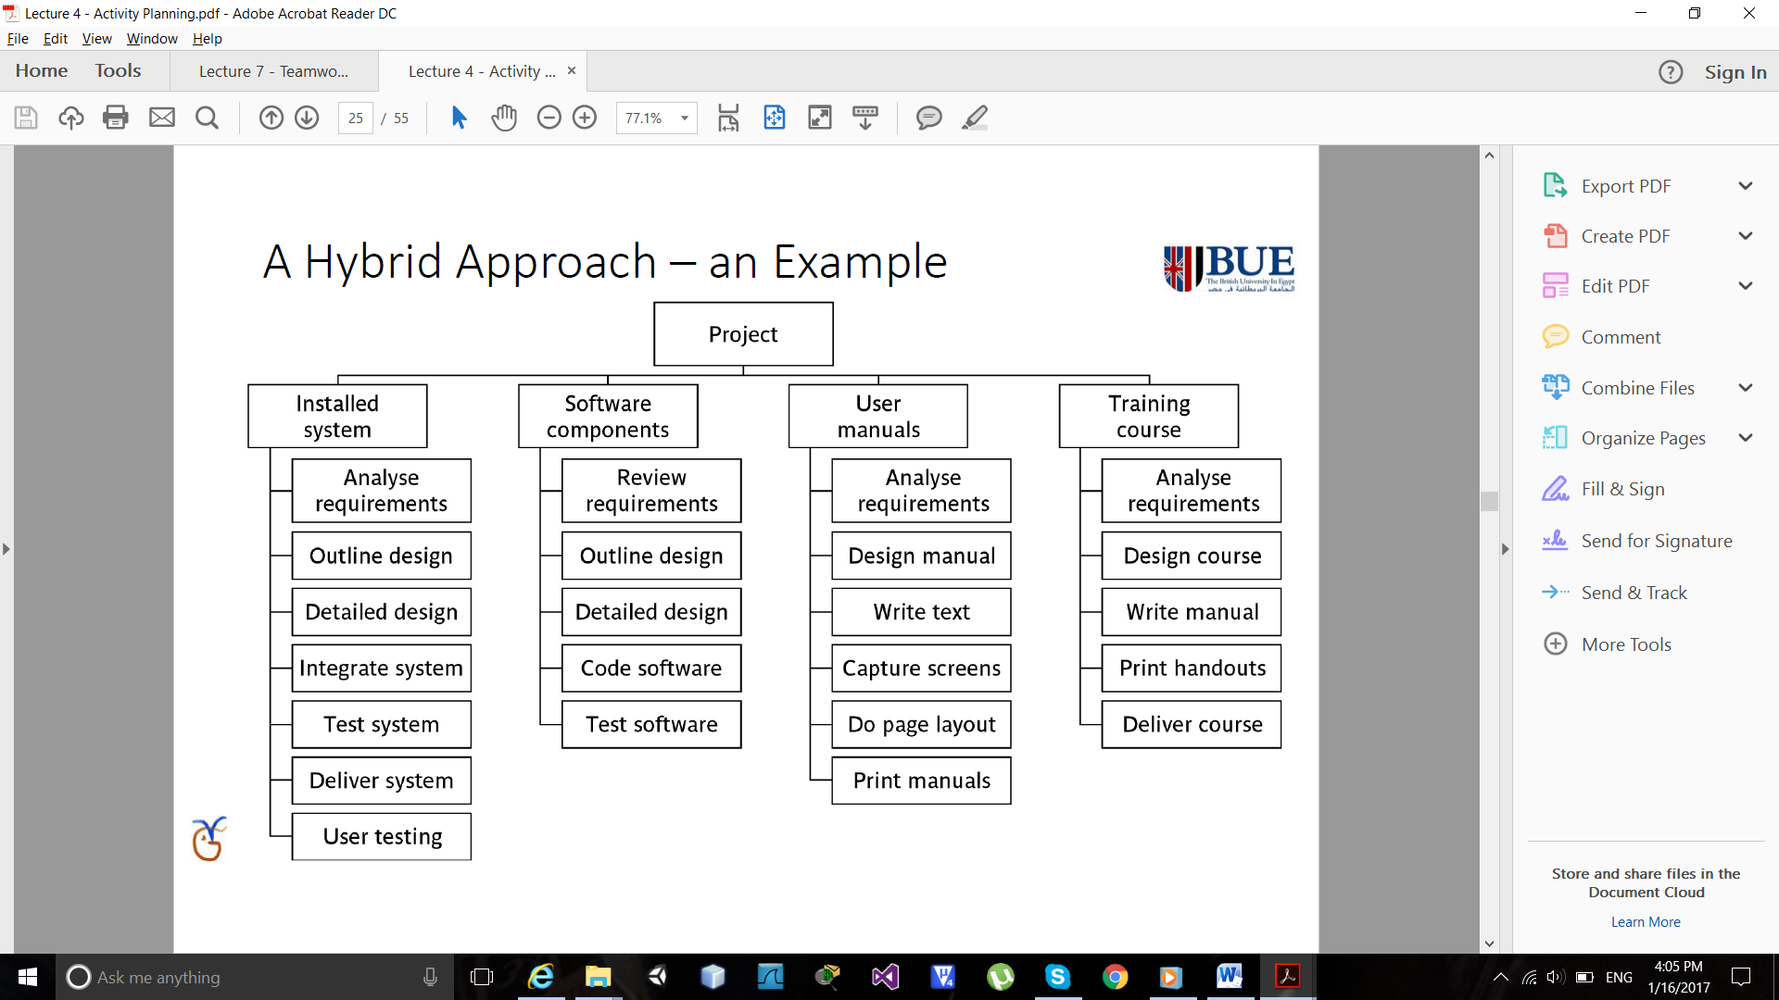

What is a Product?

The result of an activity

Can be: PC, Document, person (trained user), software update

Cannot products: activities (training), events (interview), resources and actors (developer)

Products CAN BE deliverable or intermediate

III. Product flow diagram (PFD) lecture 4/p25

Objectives of Activity Planning:

Feasibility assessment: Can we do it: Time, people -> Produce schedule

Resource allocation: check relationship between time and availability of resources

Detailed costing: After deciding on activities, schedule, resources, we decide time and costs

Motivation: Providing targets that are achievable

Coordination: timings of needed collaboration of staff from different departments, staff transfers.

When to Plan?

Planning is an ongoing process that is iteration is more detailed and more accurate.

In iteration:

During Feasibility study: purpose is time scale and risks

During project: ensuring resources availability and cash availability

During project & at final delivery: ensure time and targets set are met

What are Scheduling Techniques?

Simple sequencing

* A simple sequencing of the tasks and the responsible personnel taken into account of the resources
* Suitable for small projects. (simple bar chart)
* Sequencing and scheduling are combined

Precedence Network Models

* Models the project activities and their precedence relationship as a network
* Suitable for large software projects.( time flow chart)
* Separate sequencing from scheduling
* Sequence according to logical relationship between activities
* The most commonly used “networking” technique:
  + Critical Path Method (CPM)
  + Program Evaluation Review Technique (PERT)

Critical Path Method (CPM)

Primary objectives:

* Planning the project so that it can be completed as quickly as possible
* Identifying those activities where their delays is likely to affect the overall project completion date

Capture the activities and their inter-relationships using a graph:

* Lines are used to represent the activities
* Nodes are used to represent the start and stop of activities

Capture the activities and their inter-relationships using a graph:

* Lines are used to represent the activities
* Nodes are used to represent the start and stop of activities

Adding time dimension

* The forward pass: calculate the earliest start dates of the activities

To calculate the project completion date

* The backward pass: calculate the latest start dates for activities

Identify the critical path from the graph

Identifying critical path and critical event

* Critical event: an event that has zero slack
* Critical path: a path joining those critical events

**Lecture 5, 6**

What makes a successful project?

Delivering:

1-agree functionality 2-agree cost 3-agree quality 4-on time

Stages:

1. Set targets 2. Attempt to achieve targets

BUT what if the targets are not achievable? Project will fail

**********************

What to estimate in software project?

Software size

* Lines of code?
* No of classes / methods?
* No of database tables / queries?

Effort

* Person-hours.
* Number of hours/month

Schedule

* Calendar-days or months

**********************

Where are Estimations Done?

Estimations are carried out during different stages of software project.

* Strategic planning
* Feasibility study
* System specification
* Evaluation of suppliers’ proposals
* Project planning

**********************

What are Estimation Approaches?

1. Top-down Estimation

Based on past project data

Divide overall estimate between jobs to be done

1. Bottom-up Estimation

Use when no past project data

Identify all tasks that have to be done – so quite time-consuming

Top-down Estimation

* can be WBS or PBS
* Start at highest level
* Produce estimate for all the project
* estimate effort to different activities/products of the project

Advantages

Takes in account integration, configuration and documentation costs

Disadvantages

Underestimating the difficult low-level technical problems

Bottom-up Estimation

* can be WBS or PBS
* Start at lowest level tasks
* Estimate costs for the lowest level activities
* At each higher level add estimates for lower levels

Advantages

If the task division is accurate, the model may provide the most accurate estimates

Disadvantages

Underestimates costs of system level Needs detailed breakdown of project tasks

**********************

Define Estimation Techniques?

1. Expert judgment
2. Estimation by analogy
3. Algorithmic models
   * Albrecht function points
   * Mark II function points
   * COCOMO 81
   * COCOMO II

1-Expert judgment:

Asking for required estimate from persons that have previous experience on some parts of the problem

Advantages

* Cheap, fast, and easy to adapt to changing situations
* More accurate than algorithmic methods

Disadvantages

* The evaluation cannot be easily made visible
* difficult to know good estimates from bad ones
* Underestimation and overestimating large

2-Estimation by Analogy:

Finding similar cases to the target project

Example: calculate Euclidean distance, ANGEL tool

Advantages

* If done systematically, the estimate can be justified to project stakeholders
* If a good analogy is found, the estimation can be fairly accurate

Disadvantages

* By definition, no project is exactly equivalent
* There may not be an analogous project in the project data set
* Choosing the right features for finding analogous project

3-Algorithmic Models

Based on an algorithm (procedure of calculation)

• Function Point Methods used to estimate software SIZE.

• Constructive Cost Models (COCOMO) is used to estimate EFFORT.

Function Point Analysis

 uses the functionality of the software as a measure of its complexity.

 Analogy: For a given house, we can say how many square meters it has (LOC) or we can say how many bedrooms and bathrooms it has (FP).

Advantages: suitable for traditional applications;

Disadvantages: not suitable for real-time and embedded applications

Albrecht 5 main components:

1. External input type: input transactions from user that update internal files (Input Forma)

2. External output type: transactions that output data to user (Reports)

3. Logical internal file type: data storage used by the system (DB Files)

4. External interface file type: input/output between different computer systems (files shared with other software systems)

5. External inquiry type: transactions initiated by users that do not update the internal files (DB Query)

Improved Version of Albrecht II FP:

3 main components:

* 1. Inputs 🡪 Ni
  2. Outputs 🡪 No
  3. Entities (Storage) 🡪 Ne

FP count= Ni ∗ 0.58 + Ne ∗ 1.66 + No ∗ 0.26

COnstructive COst Model

Provide computational means for deriving software cost estimates **as functions of variables (major cost drivers)**.

**COCOMO 81:**

Effort =c*(size)^k

**Effort is measured in pm(person months)**

**Size is measured in kdsi**

**C & K are constants depended on the type of system: organic, semi-detached, or embedded.**

Organic Mode:

• Developed in familiar, stable environment

• Product similar to previously developed product

• For example, information systems

* C=2.4, K=1.05

Embedded Mode

• New product requiring a great deal of innovation

* Inflexible constraints and interface requirements
* For example, real-time systems
* C=3.6, K=1.20

• Semidetached Mode

• Somewhere between Organic and Embedded

* C=3.0, K=1.12

**COCOMO II:**

uses different models in 3 different stages of the project: **(1) application composition, (2) early design and (3) post architecture**

Effort (PM) = A*(Size)^sf x (Product of exponent multipliers)

- PM: Stands for person-months, which is the unit for effort

- Size: estimated using FPI or FPII (Unit is KLOC)

- A is a constant where A = 2.94

- Sf: better known as scale factors. An equation is used to calculate these scale factors as follows:

sf = B + 0.01 * (𝑒𝑥𝑝𝑜𝑛𝑒𝑛𝑡 𝑑𝑟𝑖𝑣𝑒𝑟 𝑟𝑎𝑡𝑖𝑛𝑔𝑠)

- B is a constant where B = 0.91

**Exponent Drivers:**

They are the following five factors which appear to be particularly sensitive to system size:

**1. Precedentedness (PREC).** Degree to which there are past examples that can be consulted.

**2. Development flexibility (FLEX**). Degree of flexibility that exists when implementing the project. (The degree to which the requirement can be met in different ways).

**3. Architecture/risk resolution (RESL).** Degree of uncertainty about requirements.

**4. Team cohesion (TEAM).** The degree to which the team is large and dispersed.

**5. Process maturity (PMAT).** The degree to which the process of software production is structured and organized.

**Effort Multipliers for the Early Design Stage:**

**RCPX** Product reliability and complexity

**RUSE** Required reusability

**PDIF** Platform difficulty

**PERS** Personnel capability

**PREX** Personnel experience

**FCIL** Facilities available

**SCED** Schedule pressure

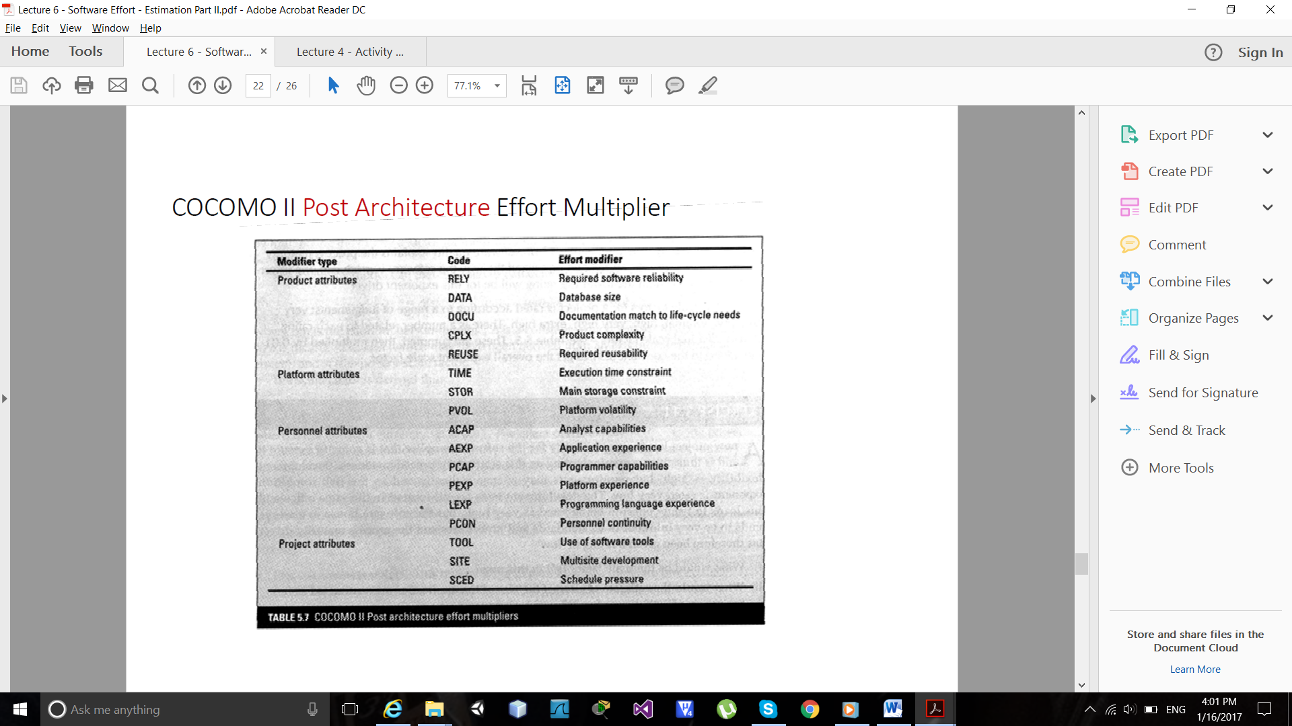

**Lecture 7**

Five basic stages of team development:

**Forming**: team get to know each other

**Storming**: conflicts arise; power and operation methods

**Norming**: conflicts settle, and group identity emerges

**Performing**: focus on tasks

**Adjourning**: team deliver and disband

Managing versus Leading?

Managing:

• making plans and estimates

• collecting and analyzing project and product data

• reporting progress

• controlling the development process

• identifying and decreasing the risk factors

Leading:

* + communicating with your project personnel and other stakeholders
  + coordinating the work activities
  + maintaining morale

Some excellent managers are poor leaders and

Some excellent leaders are poor managers

Some Attributes of a Good Leader

* Listens carefully
* Accept responsibility
* Facilitates teamwork
* Speaks with individuals on a daily basis
* Resolves conflicts
* Coaches and trains

Leadership Styles:

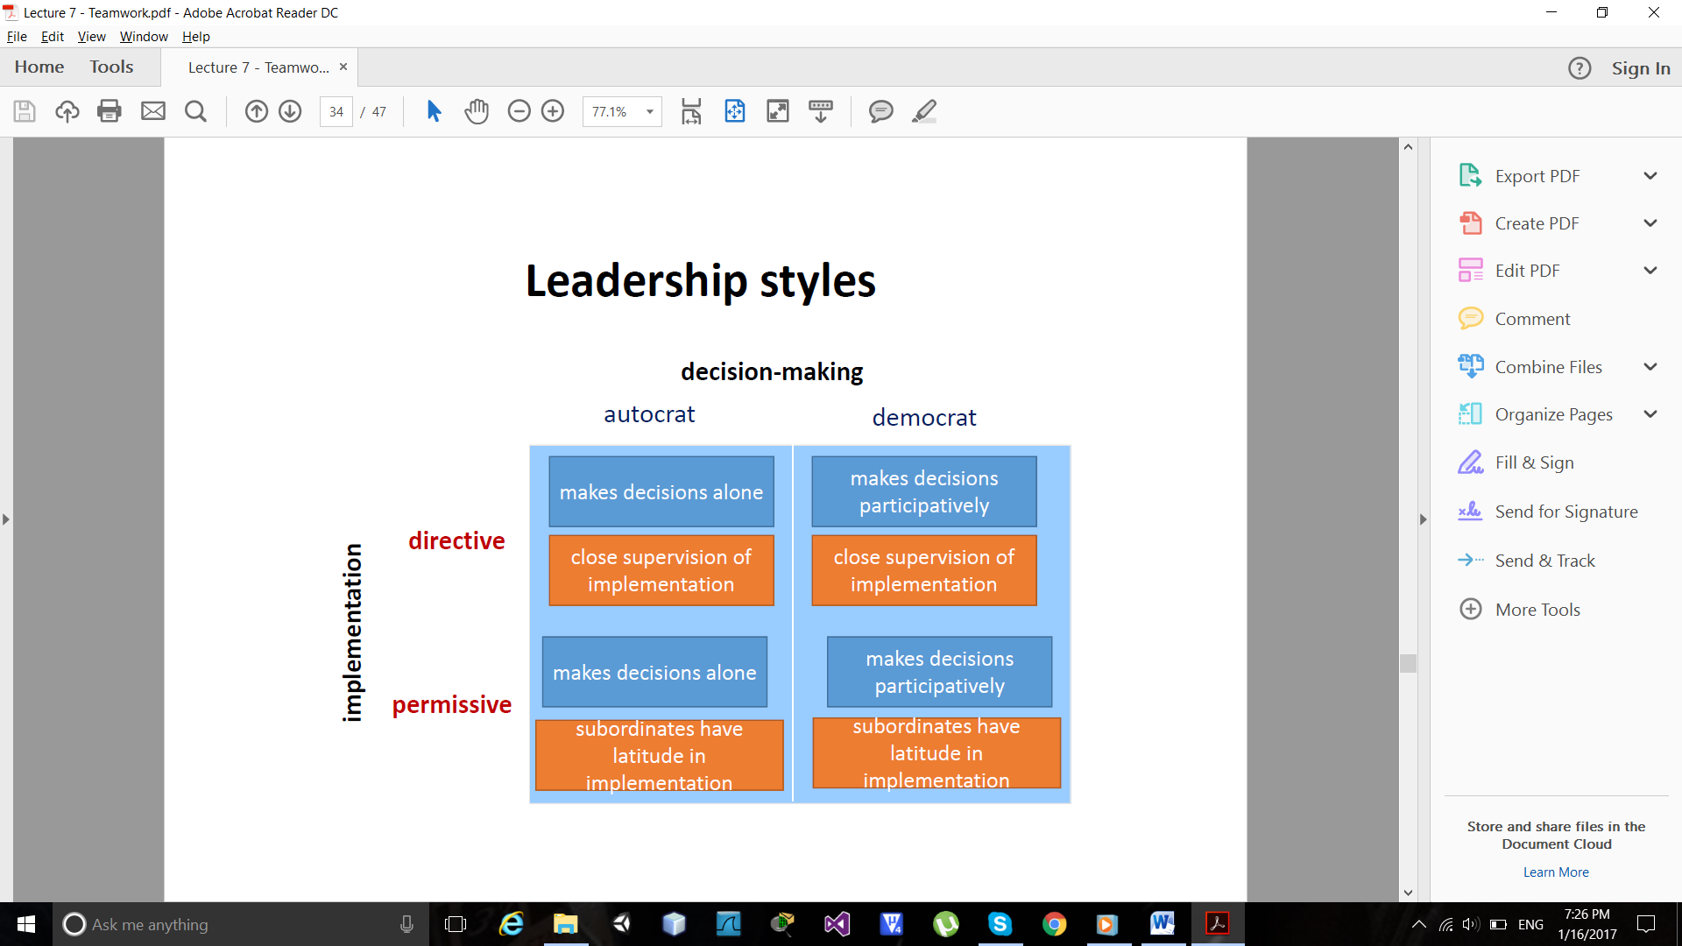

A team: is a group of individuals working in cooperative Manner toward common, shared goals

What are the factors that contribute to team formation?

1. • skills mixture
2. • Respect for one another
3. • Respect for managers and leaders
4. • Good communication skills
5. • Good communication channels

Motivation

Internal and external factors that`s stimulate desire and energy in people to make an effort to attain a goal.

1-Taylor 2-Maslow 3-Herzberg 4-Vroom 5-Hackman

Taylor’s Approach financial incentives

Piece-rates vs. day-rates

* it is difficult to isolate and quantify work done by an individual
* Difference between co-workers could damages morals and productivity.
* The problem solved by giving bonuses to project team members at the end of successful projects.

Maslow's Hierarchy – 1

1. Redefined motivational theory.
2. Proposed a more "active" model of motivation.
3. Motivations vary from individual to individual
4. He argued that all people were motivated by a hierarchical set of needs.
   * + Lowest level – food, shelter
     + Highest level – self- actualization
     + as lower ones fulfilled, higher ones emerge

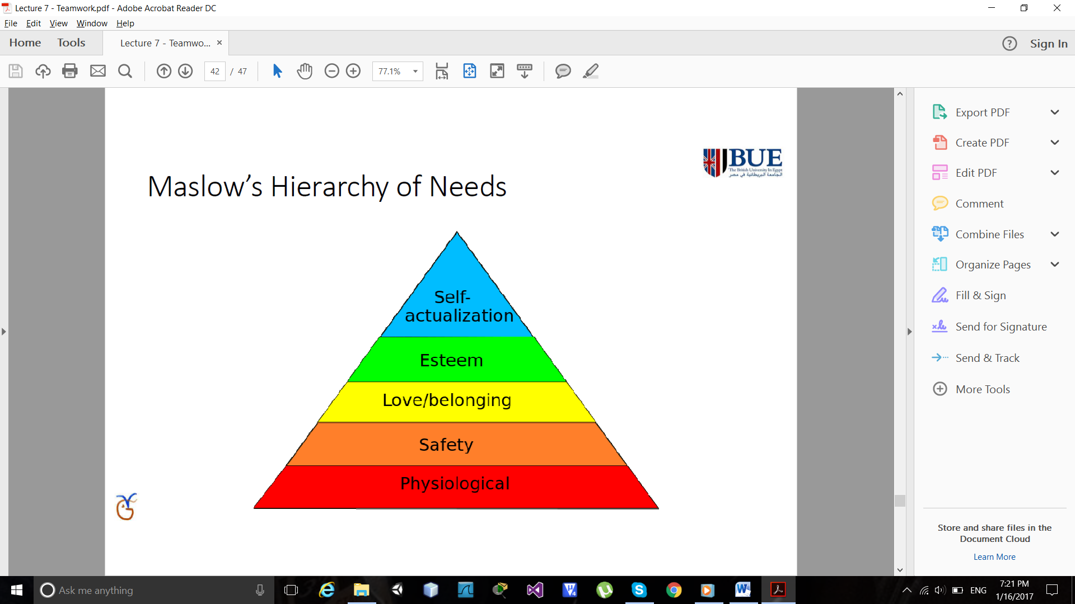

Herzberg:

Suggested two sets of factors affected job satisfaction

Maintenance factors – make you dissatisfied if they are not right

Motivators – make you feel the job is important

Vroom:

Identified three influences on motivation

* Expectancy –working harder leads to better performance
* Instrumentality – better performance will be rewarded
* observe value of the reward

Oldham-Hackman:

Identified characteristics make job ‘meaningful’

1-Skill variety 2-Task identity 3-Task significance

Methods to improve job satisfaction

* Set specific goals
* Provide feedback on the progress towards meeting those goals
* Consider job redesign

• Job enlargement

• Job enrichment

**Lecture 8, 9**

What Project Risks?

Factors that cause a project to be delayed or over-budget

*********************

What Causes Project Risks?

Planning assumptions

* We all make assumptions due to uncertainties in the early stage of the project. What happen if the assumptions turn out to be invalid?

Estimation errors

Estimation can be improved by analyzing historic data for similar tasks and similar projects

• Keep historic data of your estimation and the actual performance

• Compare your estimation and the actual value

• Classify the tasks that are easy or difficult to give accurate estimation

Eventualities

* Unexpected and unimaginable events
* Examples:
  + Hardware cannot be delivered on time
  + Requirements specification needs to be rewritten
  + Staffing problem

*********************

Risk Management Framework

Step 1: Risk Identification

Step 2: Risk Analysis and priority

1. Scenario analysis for event probability and impact (cost)

2. Risk assessment matrix (high threat risks)

3. Evaluating Risk to schedule: PERT

Step3: Risk Planning

* + Trying to reduce the uncertainties (by gathering more information )
  + Trying to lessen the impacts of risks
  + Developing contingency plans for critical risks

Step4: Monitoring risks as the project progresses

*********************

Step 1: Risk Identification Approaches

* + Generate a list of possible risks through brainstorming,

Problem identification and risk profiling.

1-Check Lists 2-Brainstorming

What Types of risks?

* Generic risk (common to all projects)
* Specific risk (only applies to individual projects)

Common Risk Factors for identification approaches?

1-Application factors 2-Changeover factors 3-Staff factors 4-Supplier factors

5-Project factors 6-Environment factors 7-Hardware factors 8-software factors

*********************

Step 2: Risk Analysis

A. Risk Exposure Measure

* Risk estimation is to assess the likelihood and impact of each hazard
* Risk exposure (risk value)
  + It is the importance of the risk
    - Risk exposure = risk likelihood × risk impact
* Fire risk likelihood = 0.001
* Impact of fire = £500,000
* Risk exposure = 500,000 x 0.001 = £500

Advantages

* The only way to compare or rank the risks
* the extra effort the better understanding of the problem

Disadvantages

* Estimation is difficult, subjective, time-consuming and costly
* Risk is not fixed for the project life time

B. Using Relative Scales

* Risk likelihood / Rank from Low, Medium to High
* Risk Impact/ Rank from Low, Medium to High

Advantages: Risk exposure is indicated by the position of the risk in a matrix

Disadvantages: The risk exposure can’t be calculated by multiplying the two factors together.

Risk Analysis Techniques: Qualitative descriptors

Step 3: Risk Planning

1. Retaining Risk / Risk acceptance

* employing staff with appropriate skills
* by using formal specification techniques

2. Avoiding Risk

* By increasing duration estimates.
* Avoid environment in which risk occurs.

3. Risk Reduction

* by prior planning(Contingency planning)
* by using prototyping(Risk Reduction Leverage (RRL)

4. Transferring Risk

* by contracting out or taking out insurance
* by quality assurance procedures and certification

5. Risk Mitigation

* Tries to reduce the impact if the risk does occur.

Risk Reduction

1-Contingency planning

* An alternative plan that will be used if a possible risk event actually occurs.
* A plan to reduce or mitigate the negative impact of a risk event.

Risks of Not Having a Contingency Plan

* Slow managerial response.
* Decisions made under pressure (dangerous and costly).

2-Risk Reduction Leverage (RRL)

* Used to carry out the risk reduction plan.
* The higher is the RRL value, the more the risk reduction plan.

RRL=RE (before) – RE (after) / risk reduction cost

If RRL > 1, Go ahead

3. Quantitative Techniques – PERT (Program Evaluation and Review Technique) evaluating the risk to Schedule

PERT was developed to take account of the uncertainty surrounding estimates of task durations.

It is like the CPM but requires 3 estimates for each activity:

1. Optimistic Time (a): shortest time in which we could expect to complete the activity.
2. Pessimistic Time (b): time we would expect the task to take under normal circumstances.
3. Most Likely Time (m): time we would expect the task to take under normal circumstances.

Expected Duration (Te) = a+4m+b/6

Standard Deviation (s) = b-a/6

**Probability of Completing the Project**

• Compute the “Z” (Z = number of standard deviations

From the mean)

• It tells the probability of completing the project in the time specified.

• (Ts) is the Target project date and (Te) is expected date.

• The z value is looked up is statistical tables, to give a probability of being delayed.

Z= T-Te/s

**Monte Carlo Simulation:**

* An alternative to the PERT technique.
* Based on calculating activity completion times for a project network **a large number of times**, each time selecting estimated activity times **randomly** from a set of estimates for each activity.
* Historic data from previous similar project can be used.

**Critical Chain:**

• The project manager is forced to focus on the activities where the actual durations exceed the target (i.e. that can be late)

• Activities which are actually completed **before** the target date are likely to be overlooked.